* **Online Customer Flow**:

Landing Page (index.jsp) will be viewed by all the online users

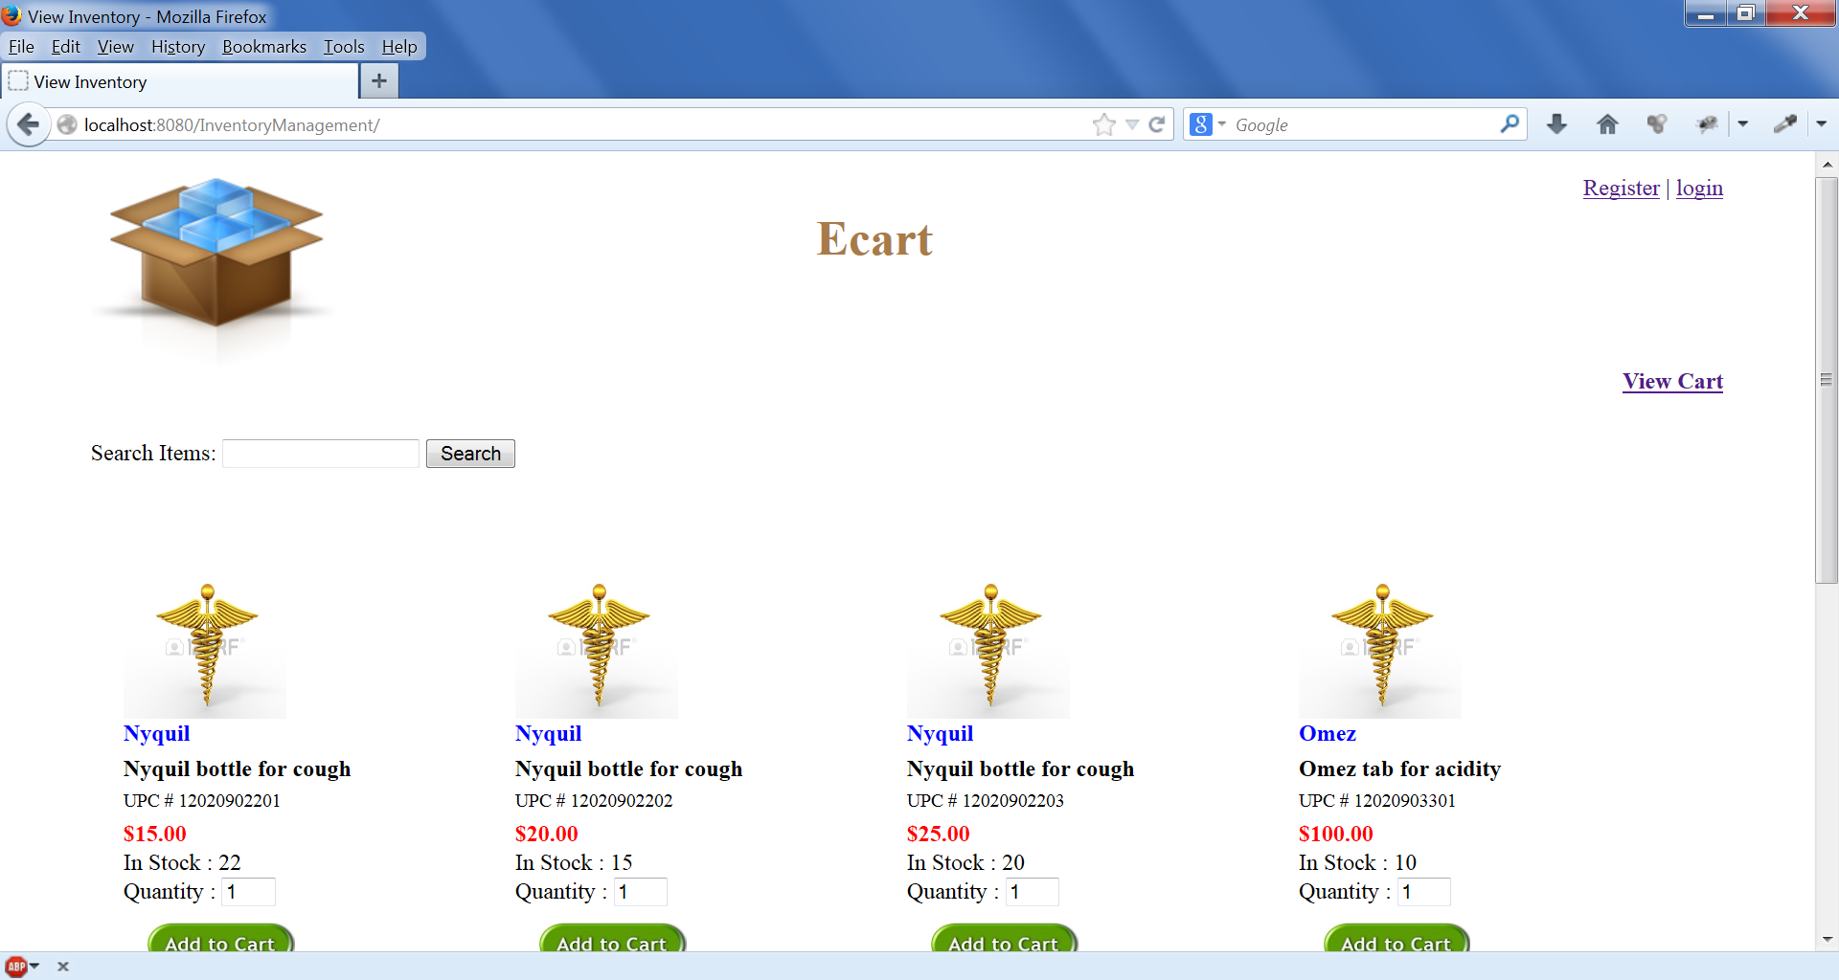

On Clicking ADD to Cart button Cart Page is displayed. User can continue the shopping or proceed to checkout.He can also update his cart by clicking update link

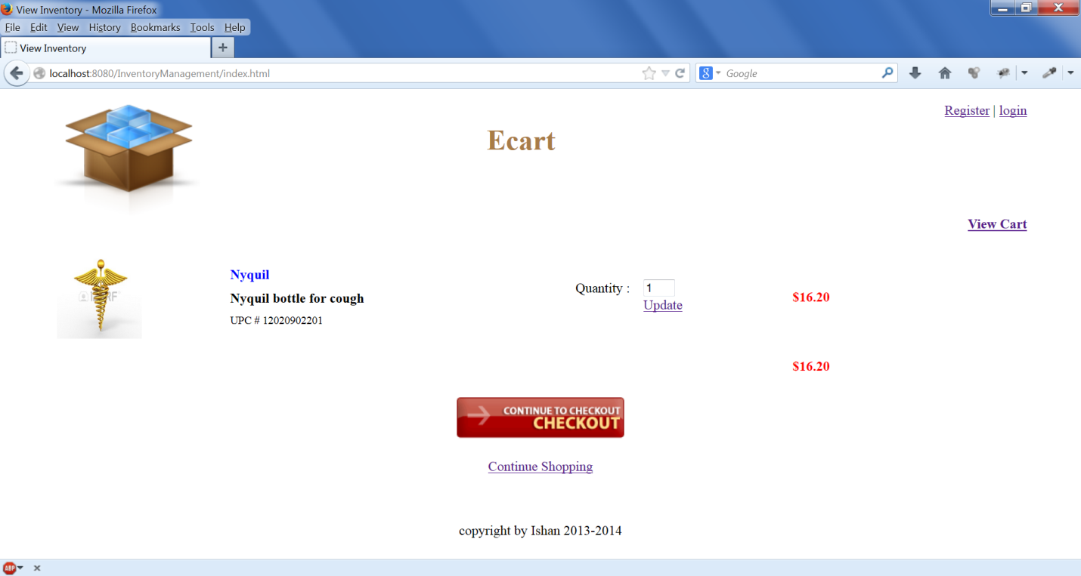

Cart updated from 1 item to 4 items:

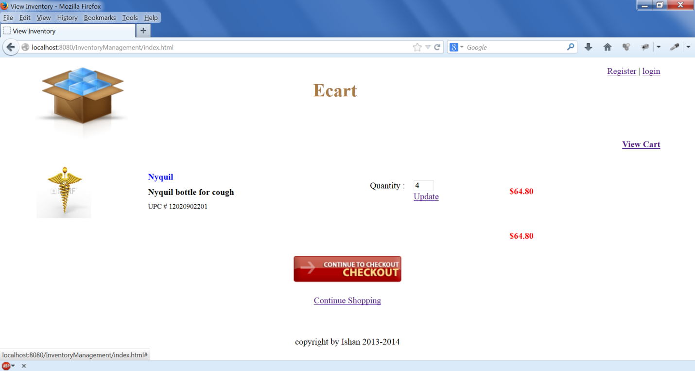

User click on checkout button, User is redirected to login page as its mandatory to create an account before checkout . If user do not have account then he can register by clicking on register link

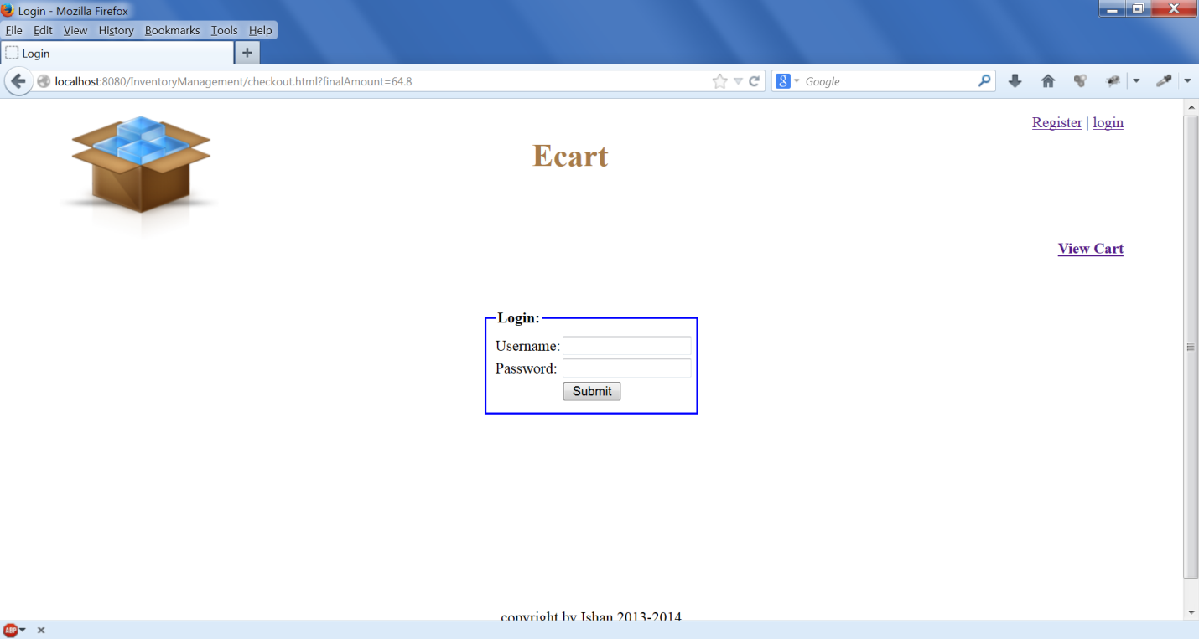

Validations provided on the login page

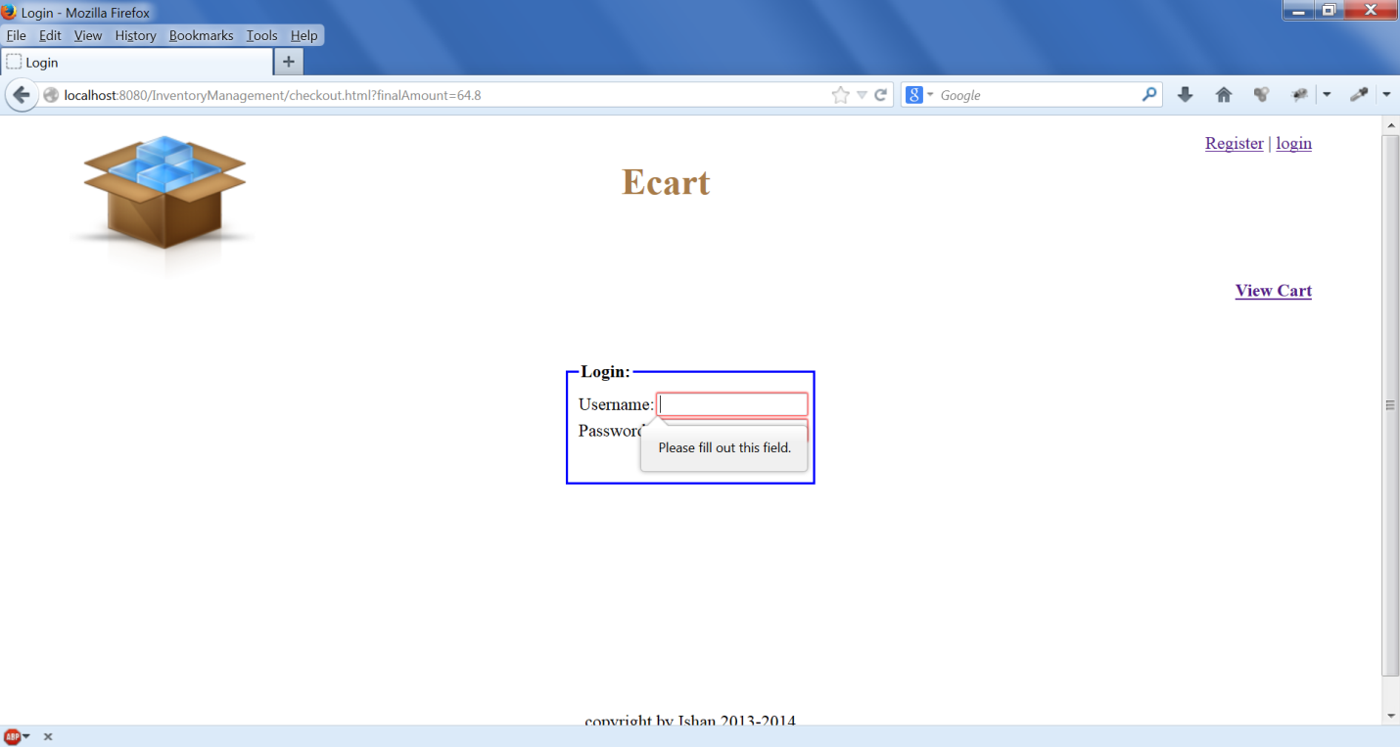

When view cart link is clicked , the user is redirected to view cart page again as the user session is still valid

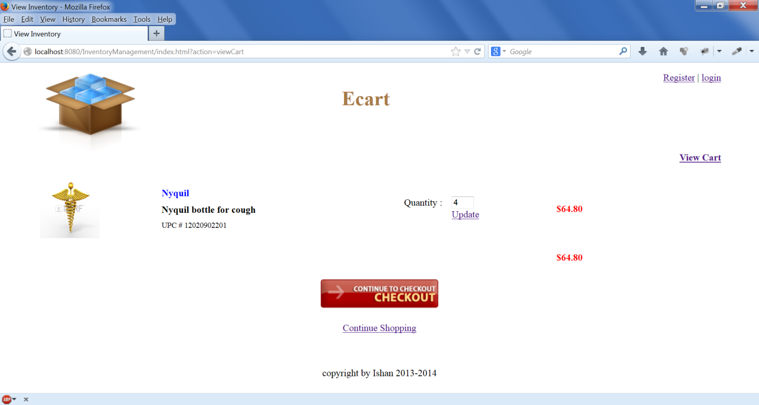

When user clicks on checkout button user is redirected to login page for login to the website



If user enters wrong userid and password is given the error message , check is done on server side

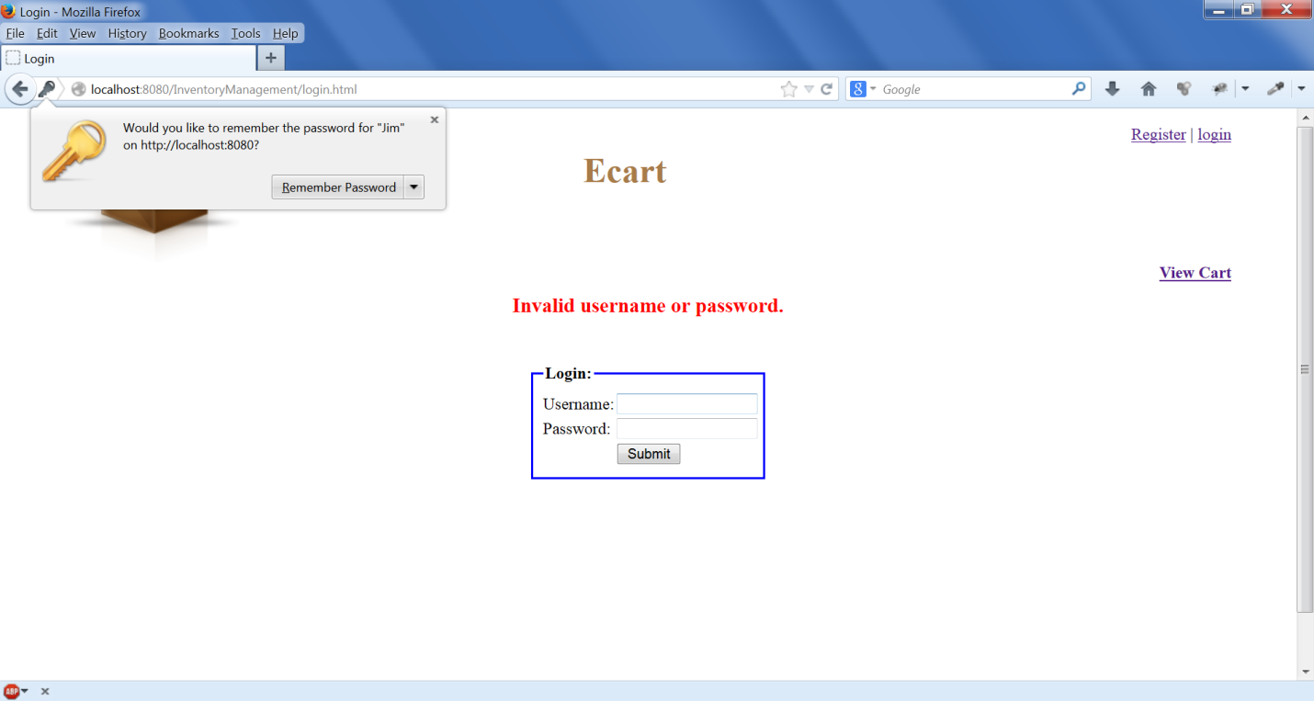

When user logs in he is redirected to the checkout page, previous page is saved in request attribute to keep track of. User details are automatically populated from session as user is stored in session.

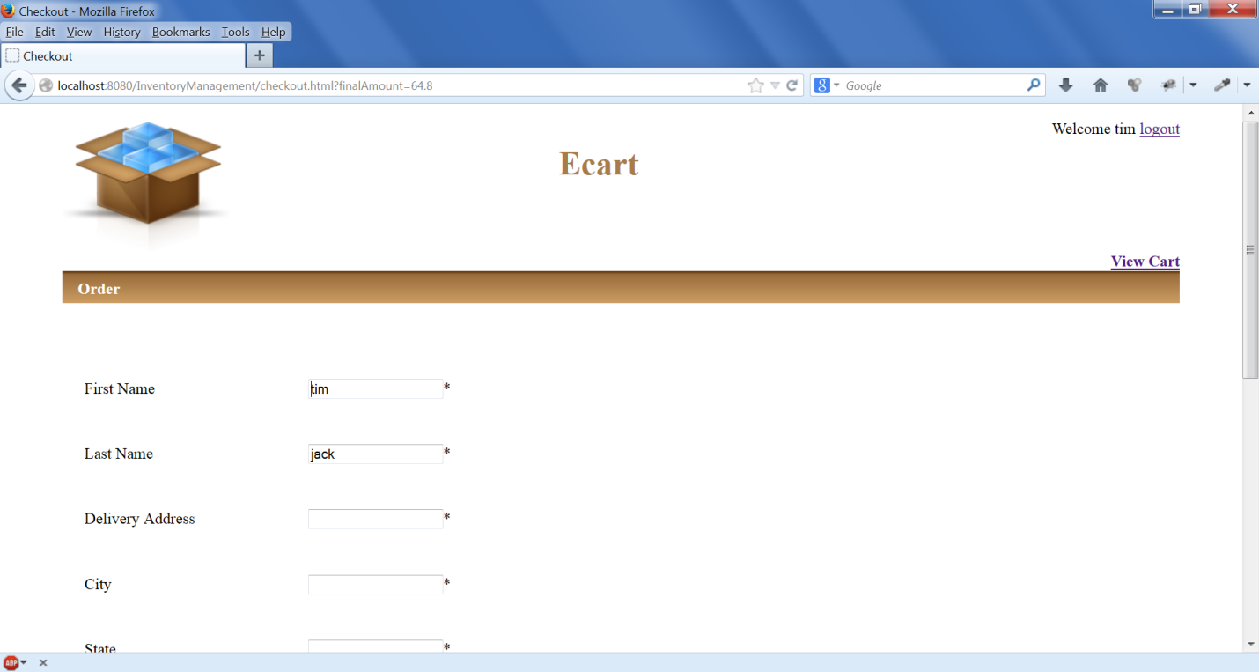

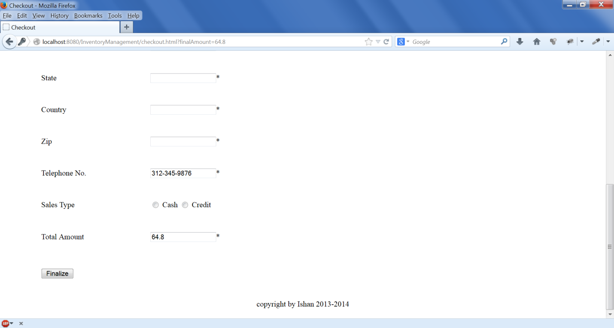

Also Amount is populated using the request object.

Checkout Page all field validations are provided.

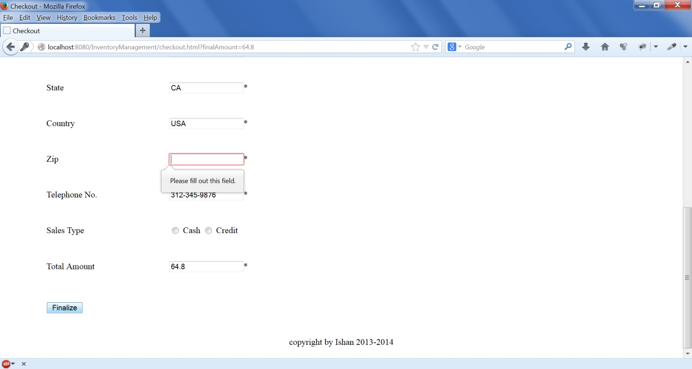

When user enters all the details and place the order,Order Number gets generated and items from inventory database are deleted. So the other users can view the exact items available in the inventory.

User gets the message with his order Number so that he can track his order based on order number.

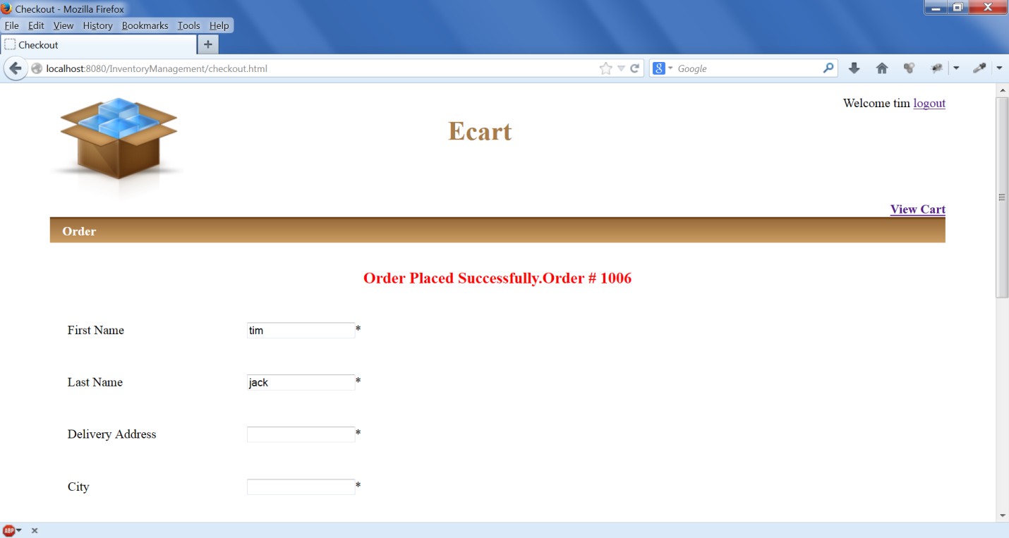

Onclick of Logout Link user is redirected back to login page

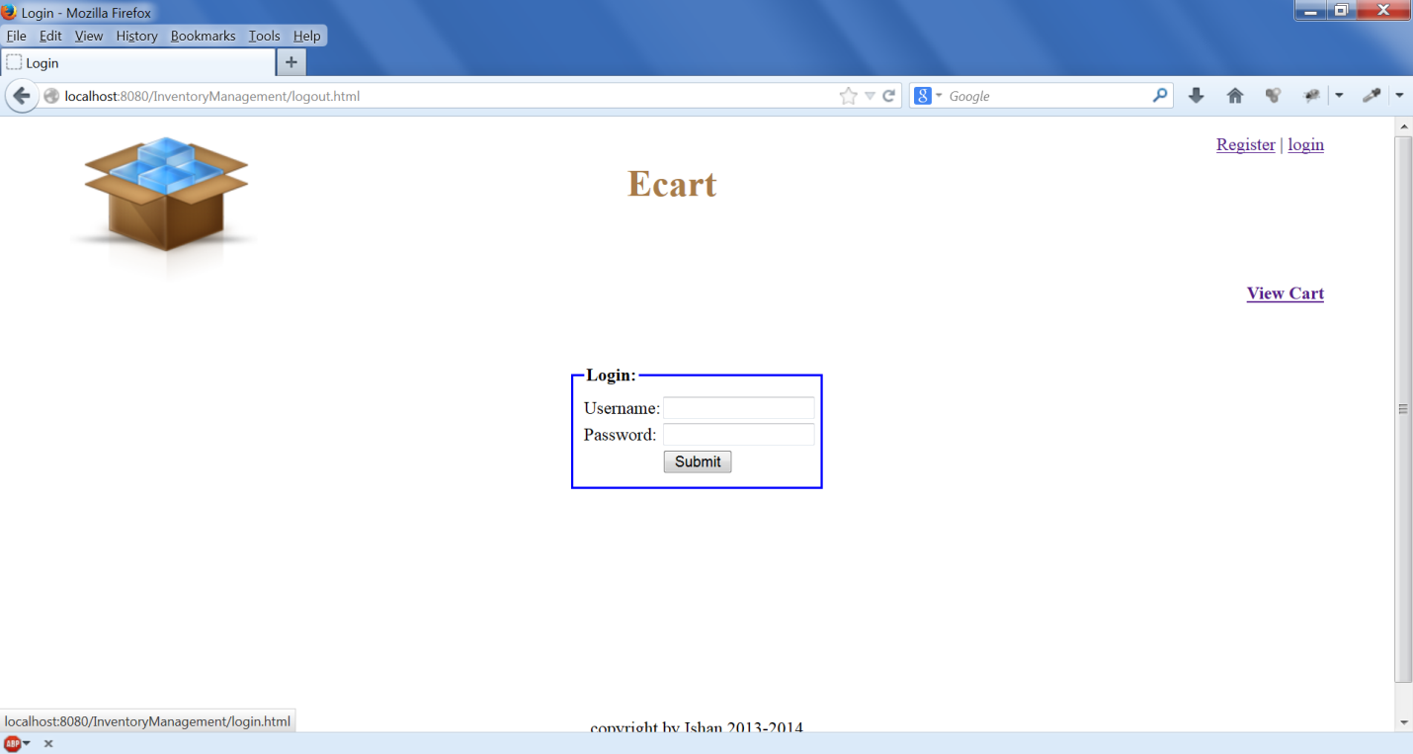

Also if user is new and wants to create website, he needs to click on the Register link ,so he gets redirected to Registration Page

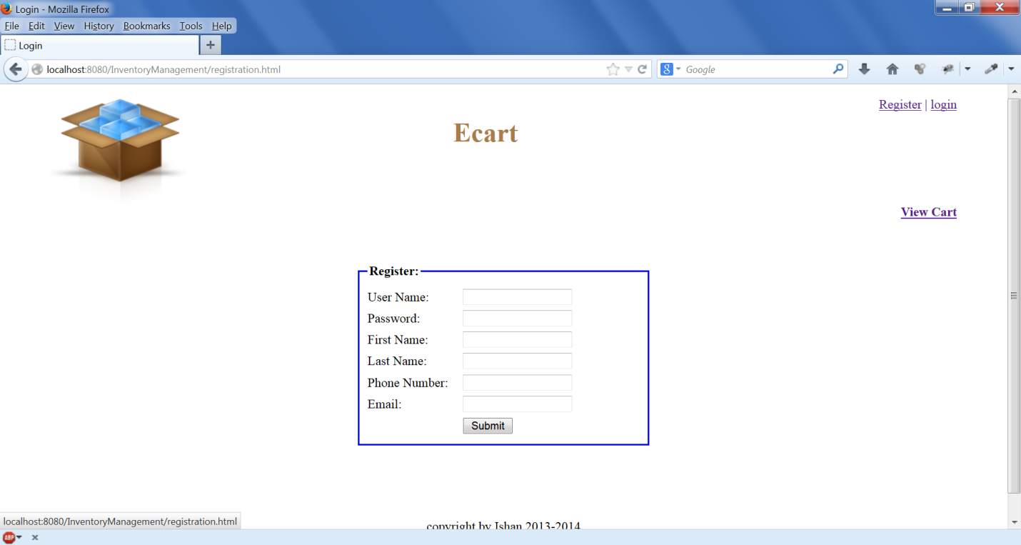

Validations provided for all the fields in the registration Page. Phone number and email address are validated using pattern matching tag of HTML5

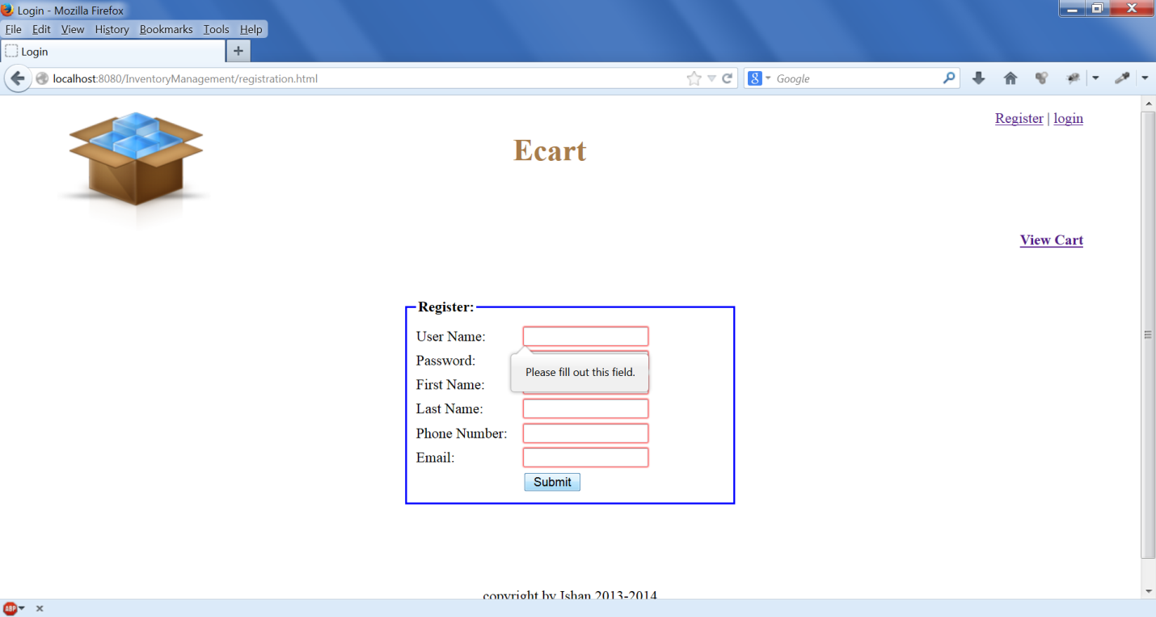

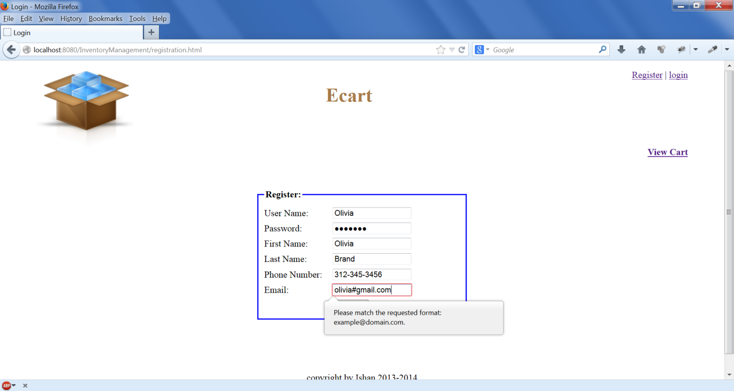

After successful registration user gets message as Regitration Successful or he will get error message.

By default user will be online customer.

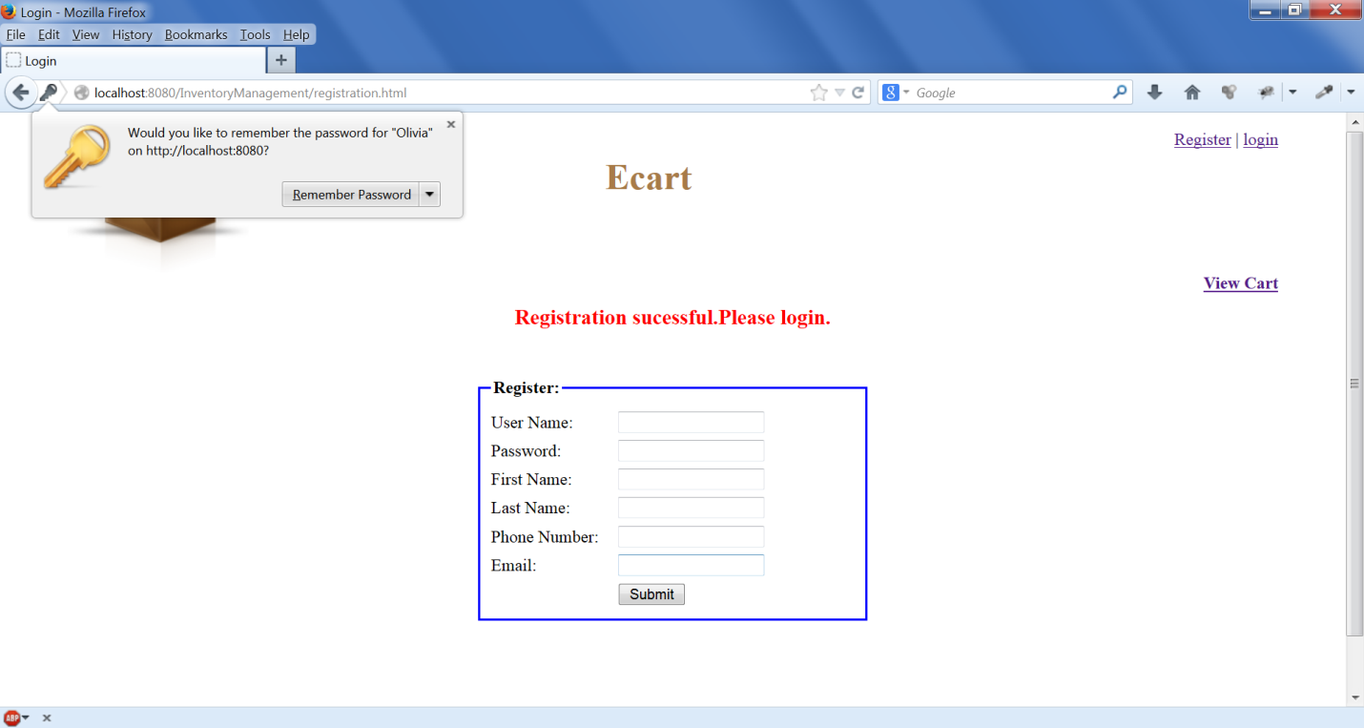

* **Flow for Inventory Manager:**

If the user role is Inventory Manager and when he logs in following screen will get displayed

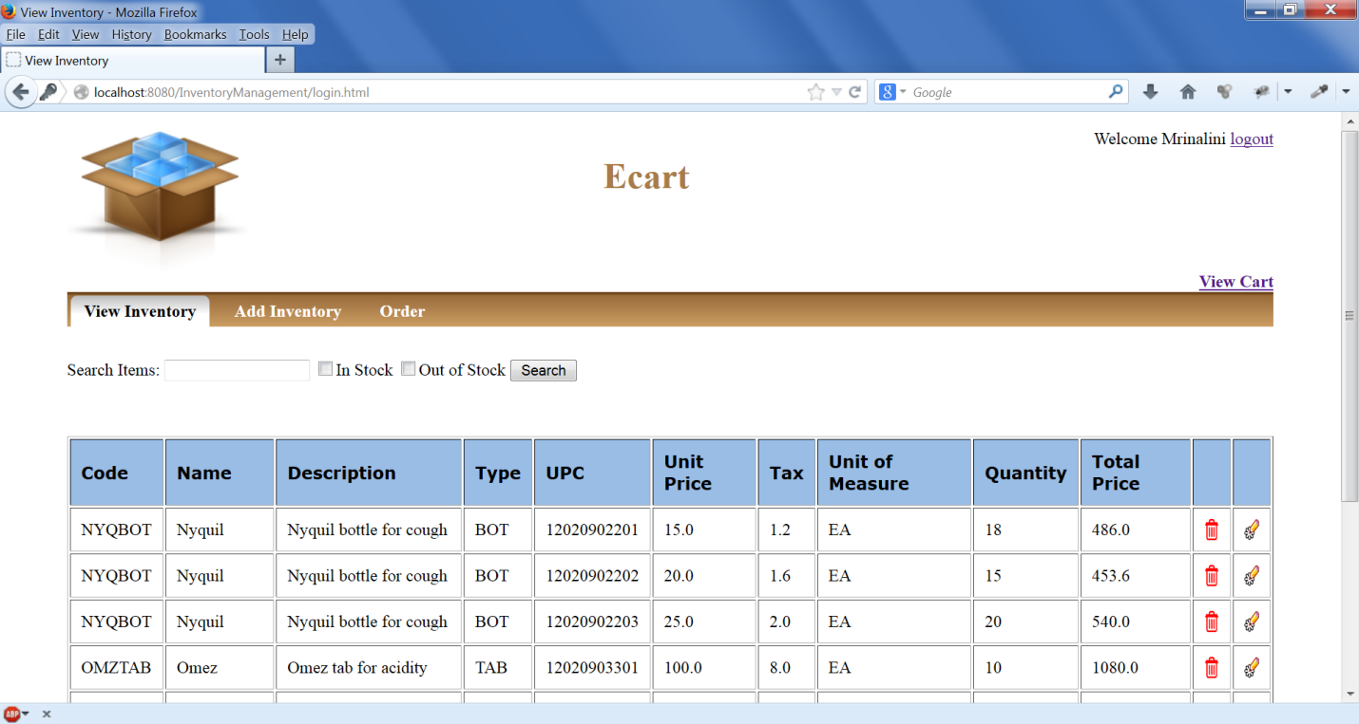

Inventory Manager can search the inventory items.

When user clicks on edit button for a item he is redirected to Edit Inventory Page.

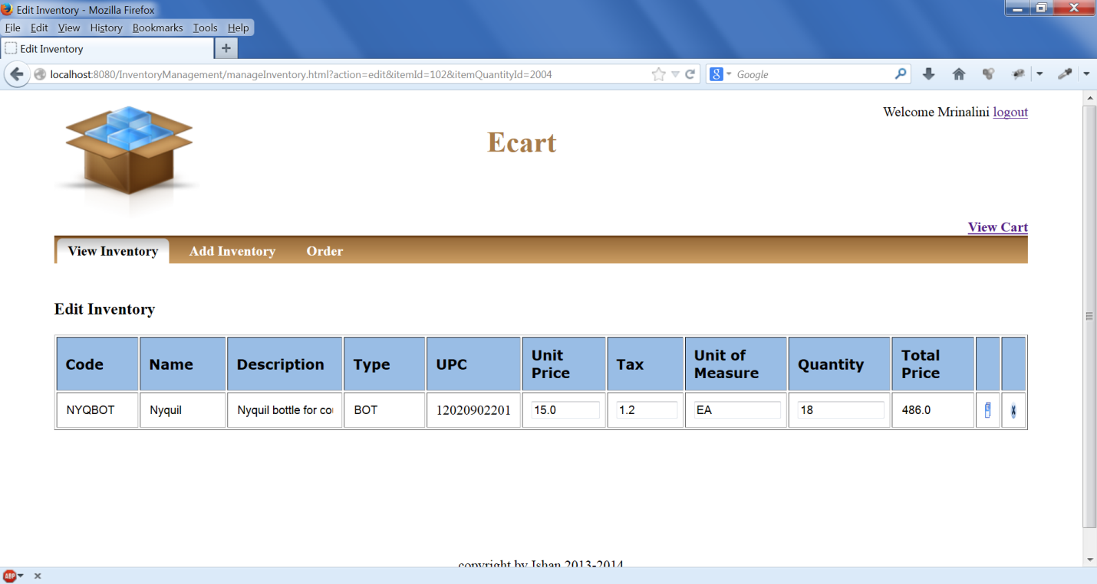

When user clicks the cancel button, then nothing will happen and the user is redirected back to View Inventory Page.

But if he changes some inventory details and click on save button he will be redirected to View Inventory Page with status message as in below Screen and records will be updated in the database.

See the first record below in screen shot the quantity got updated t 20 from 18.

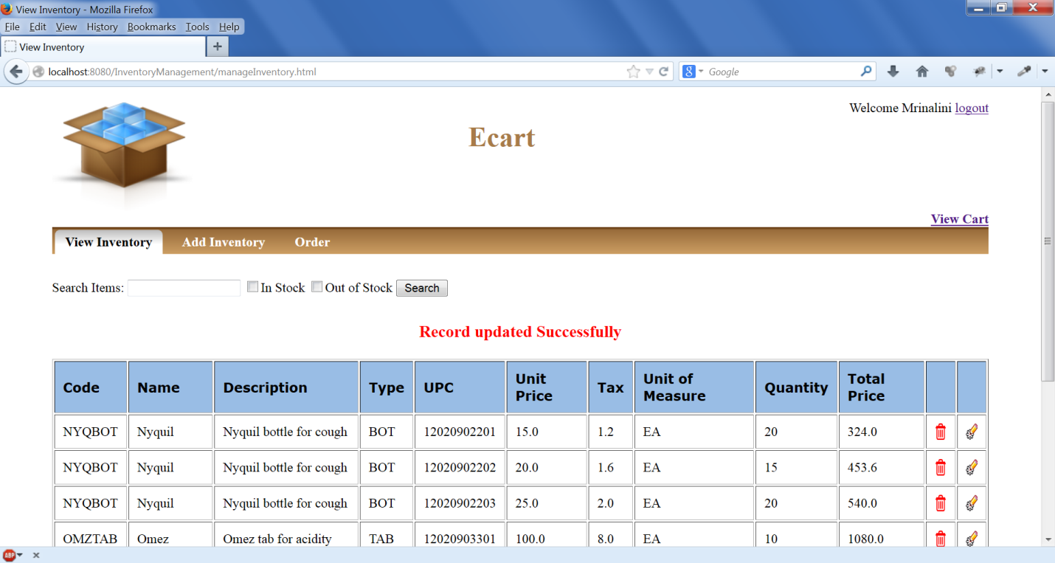

If user clicks the delete button in a particular row ,unit price, tax ,quantity, total price will become zero , and Item will become out of stock and user will be redirected to View Inventory Page with message ”Record deleted Successfully” .See the first row in below screen ,the quantity becomes zero. He can further edit the Item and update its quantity to bring it in stock.

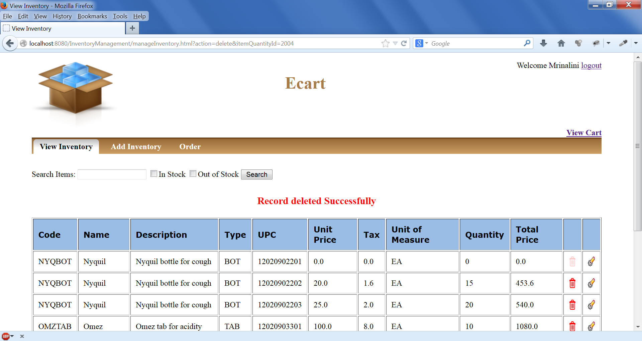

User can search Instock, Out Of Stock Items and by name or code as shown below:

**Out Of Stock Search:**

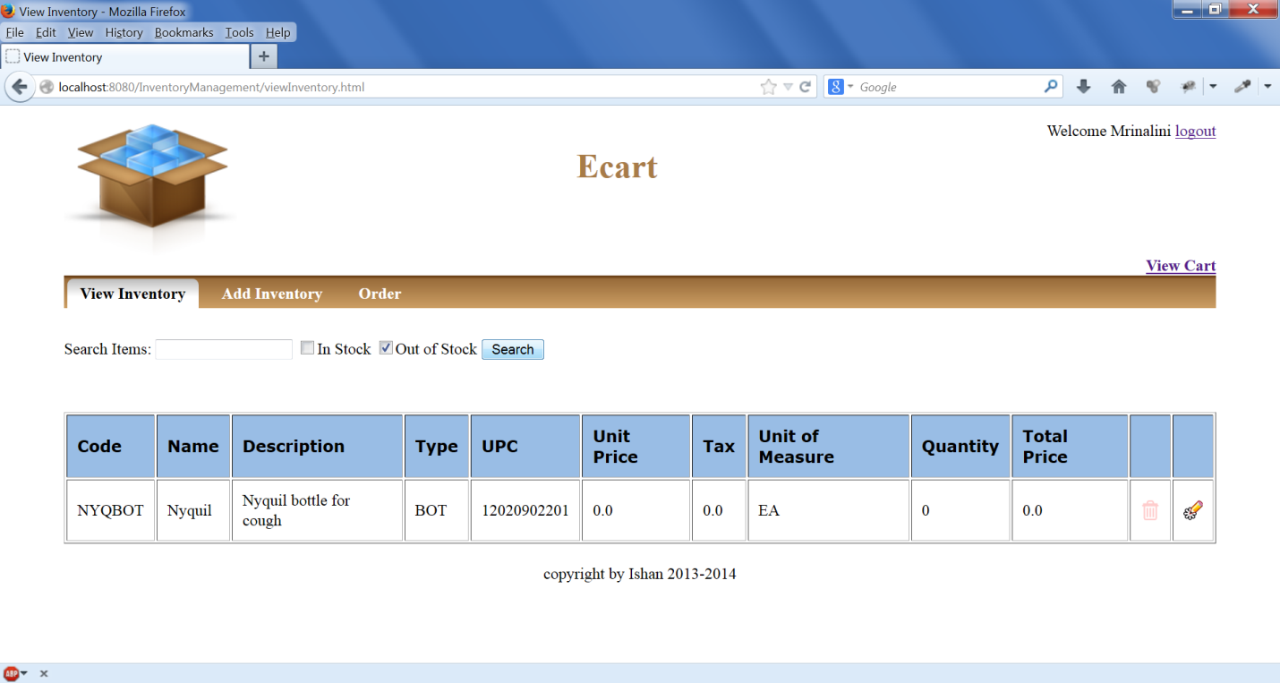

**Search by Name:**

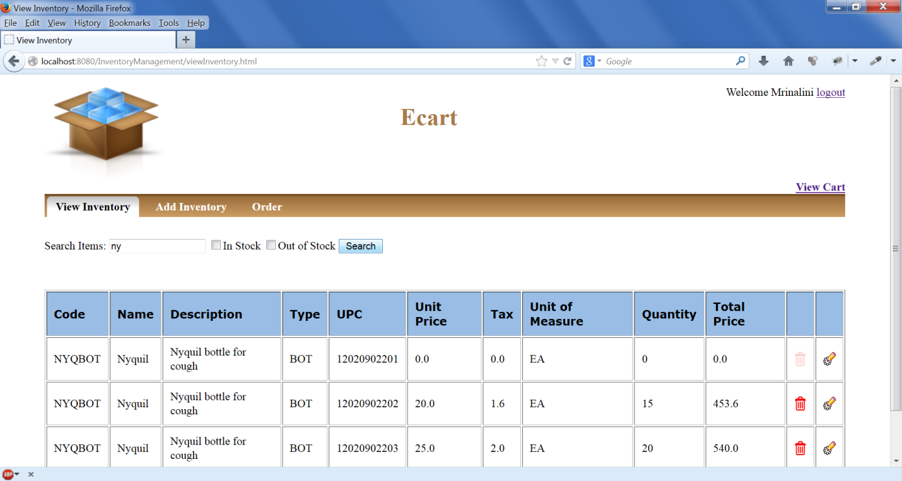

**Search by name and In Stock :**

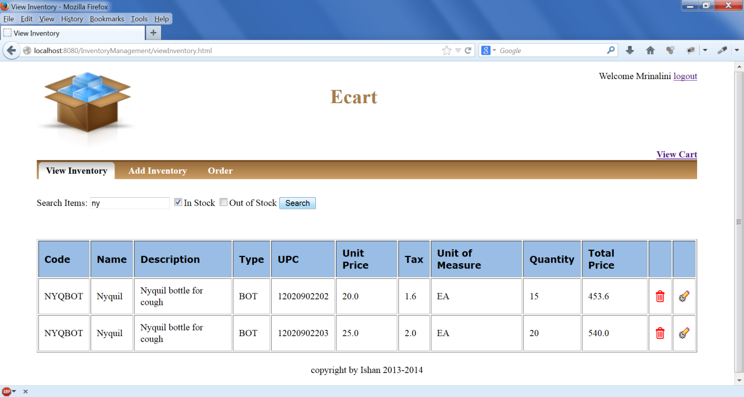

User can add new Inventory to the database by clicking Add Inventory Menu.

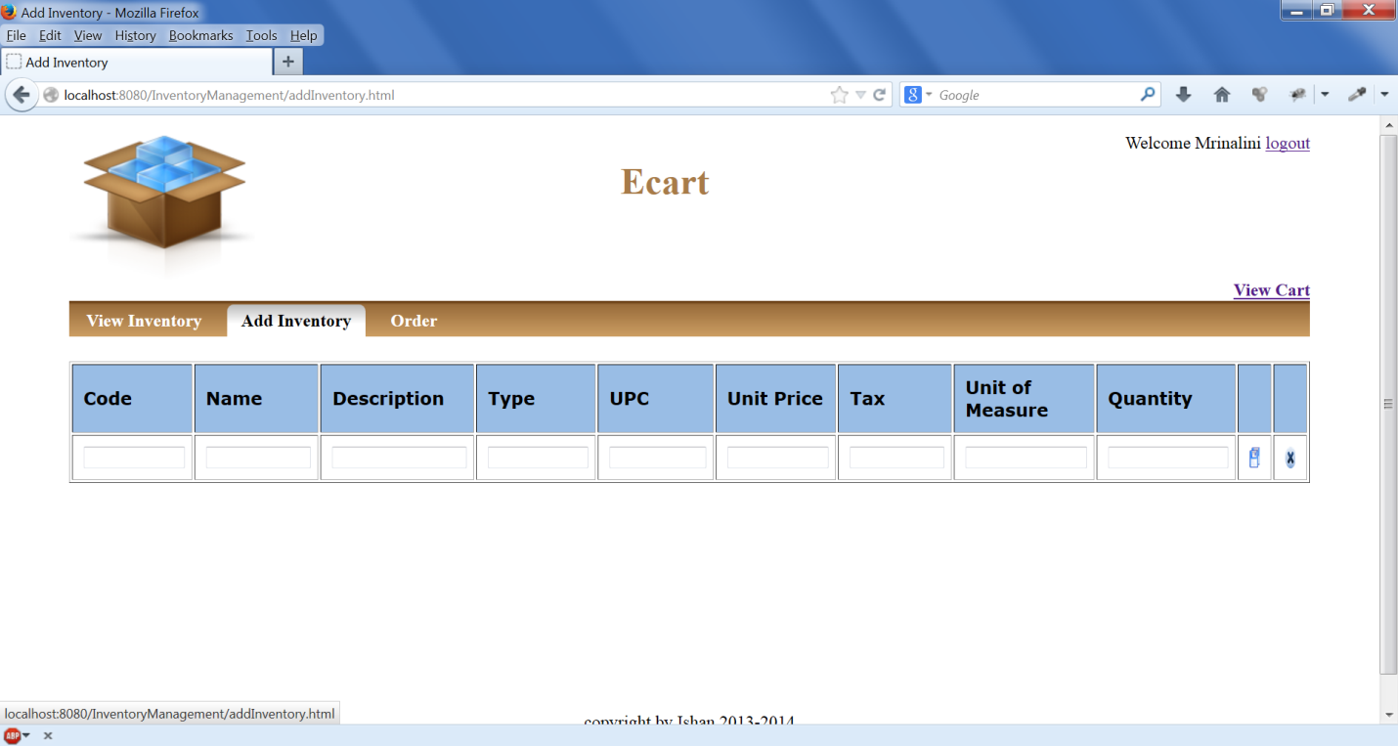

Also Inventory Manager is provided option to do online shopping as the online Customer by clicking order button.

